|  |  |  |  |
| --- | --- | --- | --- |
| **Project** | **Release** | **Sprint** | **Feature** |
| int ProjectId;  List<Feature> Backlog;  List<Release> Releases; | List<Sprint> Sprints; | List<Feature> Features;  Datetime dueDate;  int amountOfCompletedWork;  int amountOfRemainingWork; | Developer Assignee;  int estimatedWork;  int remainingWork;  int completedWork; |

|  |  |  |
| --- | --- | --- |
| **User** | **Developer** | **ProjectManager** |
| int UserId;  String Name; | Boolean estimateFeature(int featureId)  Boolean updateFeature(int featureId) | Boolean AddFeatureToRelease(int featureId) |

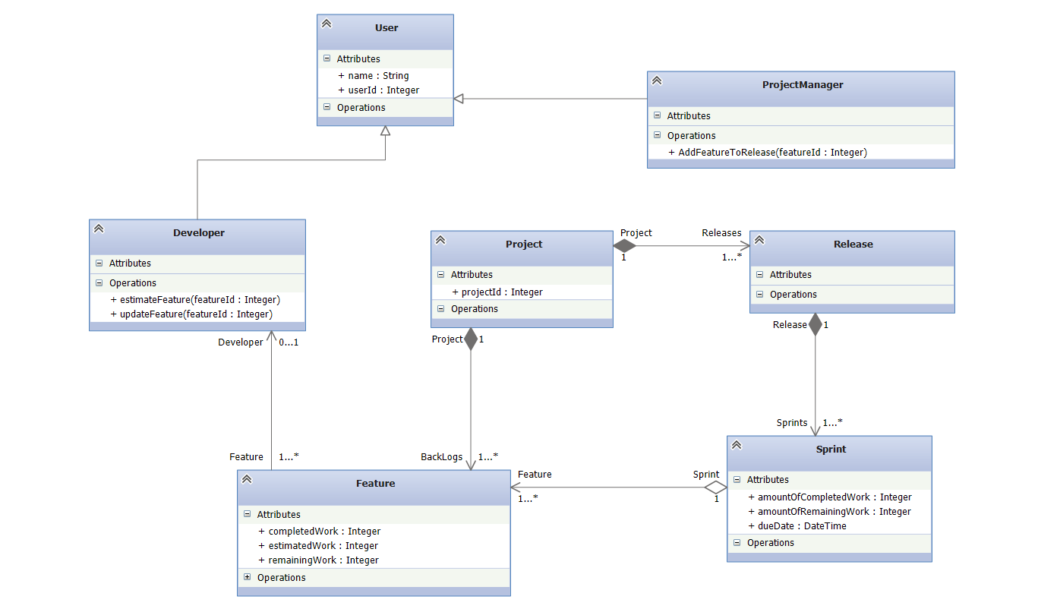

**import** java.util.Date;

**import** java.util.List;

**public class** User {

**int** UserId;

String name;

}

**public class** Developer **extends** User{

**boolean** estimateFeature(){

**return** **true**;

}

**boolean** updateFeature(){

**return** **true**;

}

}

**public class** ProjectManager **extends** User{

**boolean** addFeatueToRelease(){

**return** **true**;

}

}

**public class** Project{

**public** Project(){

Backlog = **new** ArrayList<Feature>();

Releases = **new** ArrayList<Release>();

}

List<Feature> Backlog;

List<Release> Releases;

}

**public class** Release{

**public** Release(){

Sprints = **new** ArrayList<Sprint>();

}

List<Sprint> Sprints;

}

**public class** Sprint{

**public** Sprint(){

Features = **new** ArrayList<Feature>();

}

List<Feature> Features;

Date dueDate;

**int** amountOfCompletedWork;

**int** amountOfRemainingWork;

}

**public class** Feature{

Developer Assignee;

**int** estimatedWork;

**int** remainingWork;

**int** completedWork;

}